Chapter 5 – Volcanoes and Volcanic Eruptions

Volcanic activity/volcanism is directly related to plate tectonics and most active volcanoes are located near plate boundaries.

* 2/3 of all active volcanoes on land are located along the Ring of Fire which surrounds the Pacific Ocean

Mid ocean ridges and subduction zones are sites where molten rock reaches the surface

* Magma is molten rock
* Lava is magma that reaches and erupts at the earth’s surface

Importance of how volcanoes work? To understand/predict volcanic hazards

Magma comes from the asthenosphere, where rock is close to its melting temperature

* 3 ways the silicate rocks can melt:
  + decompression melting: occurs when the pressure exerted on hot rock within the asthenosphere is reduced
    - happens at divergent plate boundaries, continental rifts and hot spots
  + addition of volatiles: lowers the melting temperature of rocks by helping break chemical bonds within silicate materials
    - volatiles: chemical compounds that exist in a gaseous state at Earth’s surface and evaporate easily
  + addition of heat: can induce melting if the temperature of the rocks exceeds the melting temperature of silicate rocks at that depth

Magma – composed of melted silicate minerals and dissolved gases, most abundant elements are silicon and oxygen

* contains also small but significant amounts of dissolved gases, mostly water vapour and carbon dioxide
* volcanic rocks are named depending on the amount of silica present in the rock:
  + basalt, andesite, dacite, rhyolite
* viscosity – resistance to flow – affected by temperature and composition
  + silica rich magma (felsic) = high viscosity
    - ex.rhyolite
  + low silica content magma (mafic) = low viscosity 🡪 as it flows away from the vent and cools, the viscosity increases causing the flow to move more slowly and change form
    - ex. basalt

Volcano Types

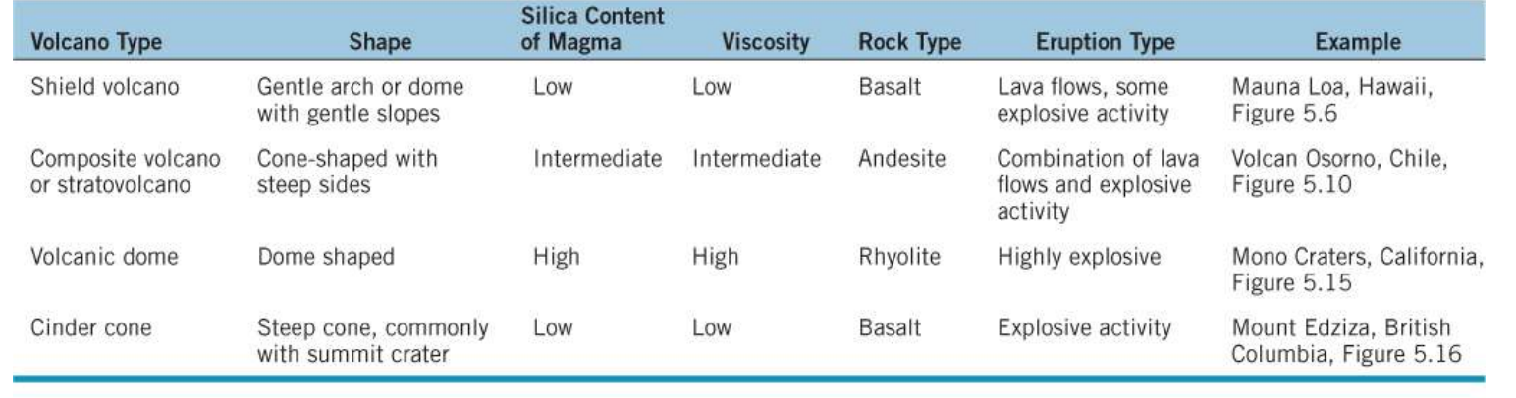

1. Shield volcanoes – largest volcanoes on Earth

* Gently sloping sides, broad summits and a broad arc
* Caused by non-explosive eruptions of very hot, low viscosity, basaltic magmas
  + Basaltic magmas have not undergone fractionation – crystallization process of different minerals in a slowly cooling magma
* Magma erupts through vents (openings) in the volcano and flow down its sides – sometimes for dozens of kms
  + Lava can flow for many kms away from a vent through underground lava tubes
    - The walls insulate the magma, keeping it hot and fluid

1. Composite volcanoes – stratovolcanoes

* Derived from the interlayered lavas and pyroclastic deposits that characterize these conical volcanoes
* erupt less frequently than active shield volcanoes but they involve explosive magmas
* very viscous magma that doesn’t flow very far
* deadly eruptions and destructive

1. Volcanic domes – steep sided mounds of lava that form around vents from the eruption of high viscous, silica rich magmas
2. Cinder cones – scoria cones – relatively small volcanoes made up of nut to fist sized pieced of red or black basalt

* Round or oval in surface form and commonly have a crater at their top
* Found on the flanks of larger volcanoes, along normal faults and along cracks or fissures

1. Maars – violent interaction of magma and groundwater

* Conversion of water into steam drives a violent explosion that forms a crater, similar to a meteor impact

1. Ice contact volcanoes – eruptions beneath or against glaciers

* Subglacial volcanoes that periodically erupt, melting large quantities of ice and this producing huge outburst floods (jokulhlaups)
* Odd shapes from rapid chilling of lava when it comes in contact with water and ice
  + Rapid cooling of the lavas produced forms called pillows, that break up and form volcanic deposits called pillow breccias

Volcanic features

1. Craters – depressions at the top of volcanoes that form by explosion or collapse of the summit area
2. Calderas – circular to oval depressions that form during explosive ejection of magma and subsequent collapse of a volcano
   * Largest and most deadly type of eruption, but are rare
3. Volcanic vents – openings through which lava and pyroclastic debris erupt
   * Some vents are circular while others are elongating cracks called fissures
     + Extensive fissure eruptions have produced huge accumulations of nearly horizontal lava flows called flood basalts
4. Hot springs – groundwater becomes heated when it comes in contact with hot rock. When it discharges at the surface – hot springs/thermal spring
5. Geysers – groundwater boils in an underground chamber to produce periodic, steam driven releases of steam and hot water
6. Resurgent calderas & super eruptions
   * Very rare but extremely violent eruptions from supervolcanoes
   * Produce huge amounts of ash and form calderas

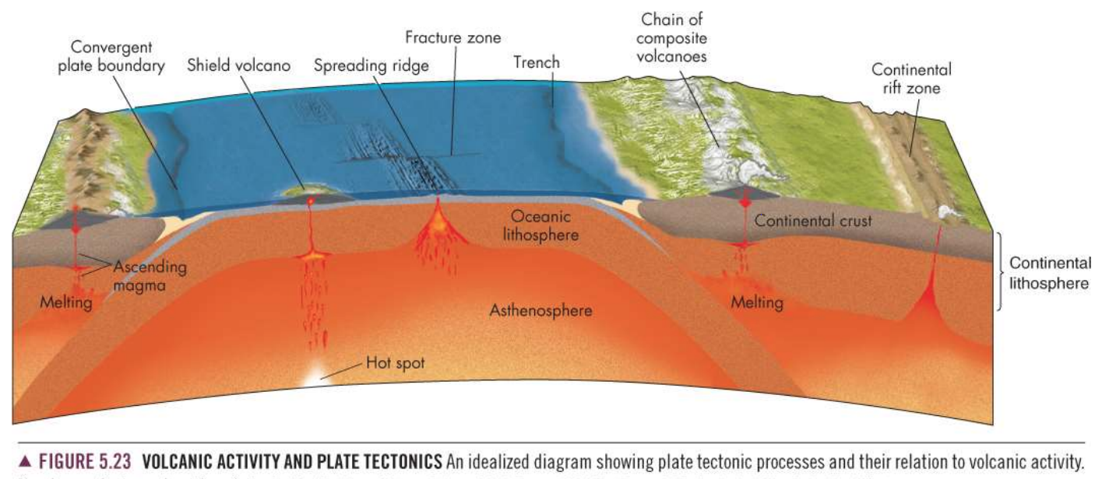

Geographic Regions with Active Volcanoes

* Ring of Fire
  + Pacific ocean subduction zones
  + Highest risk in Canada is in NW and central BC
* Hot Spots
  + Hawaii and Yellowstone National Park
* Volcano that poses the greatest risk to Canada
  + Mt.Baker in northern Washington state; an eruption could spread ash over Vancouver

Volcanic hazards

* 50 to 60 volcanoes erupt each year
  + many of them happen in sparsely populated areas so they do not cause much if any loss of life or economic damage
* past 100 years about 100,000 people have died from volcano eruptions
* 500 million people live close to volcanoes
  + japan, mexico, Philippines, Indonesia
  + western north America

Primary effects – lava flows, ash fall, volcanic bombs, pyroclastic flows, pyroclastic surges, lateral blasts and poisonous gases

Secondary effects - lahars, debris avalanches, landslides, groundwater and surface contamination, floods, fires and tsunamis

Volcanic Explosivity Index (VEI) – quantifies the size of eruption with a scale

Lava flows – occur when magma reaches the surface of earth and magma begins to move slowly/rapidly depending on viscosity and temperature

* basaltic lava flow is the most common
  + pahoehoe: hardens with a smooth and ropy texture, traveling at speed up to a few kms/hr
  + aa: harden with a rough, blocky texture and is more viscous so travels at rates of a few metres a day
* pyroclastic flows – avalanches of hot gas, ash and volcanic rock fragments that cascade down the slopes of a volcano during an explosive eruptions
  + can move at speeds up to 150km/h
* pyroclastic surges – dense clouds of hot gas and rock debris produced by explosive interaction of water and magma
  + can move at speeds of more that 360km/h
* lateral blasts – rock fragments, gas and ash that are blown horizontally from side of volcano
* ash fall – tremendous quantity of finally broken volcanic rock and gas carried downwind
  + destroys vegetation
  + surface water conatamination
  + respiratory illnesses
  + aircraft engines can experience failure
* poisonous gases – carbon dioxide, carbon monoxide, sulphur dioxide, hydrogen sulphide, chlorine, hydrofluoric acid – emitted during eruptions
* edifice or sector collapse – the flank of a volcano may collapse due to ground shaking from steam venting, magma ascent or an earthquake
* debris flows and other mass movements
  + lahars – large amounts of loose volcanic ash and other pyroclastic material become saturated with water and rapidly move downslope

Linkages between volcanoes and other natural hazards

* earthquakes – commonly precede or accompany volcanic eruptions
* landslides – sector collapses can cause tsunamis if they enter water
* fire – hot lava may ignite plants and structures
* climate change – volcanic ash from an eruption can temporarily cool climate

Minimizing the volcanic hazard

* forecasting the probability of volcanic eruption is determined by information gained by:
  + monitoring seismic activity
  + thermal, magnetic and hydrologic monitoring
  + land surface monitoring
  + monitoring volcanic gas emissions
  + geologic history

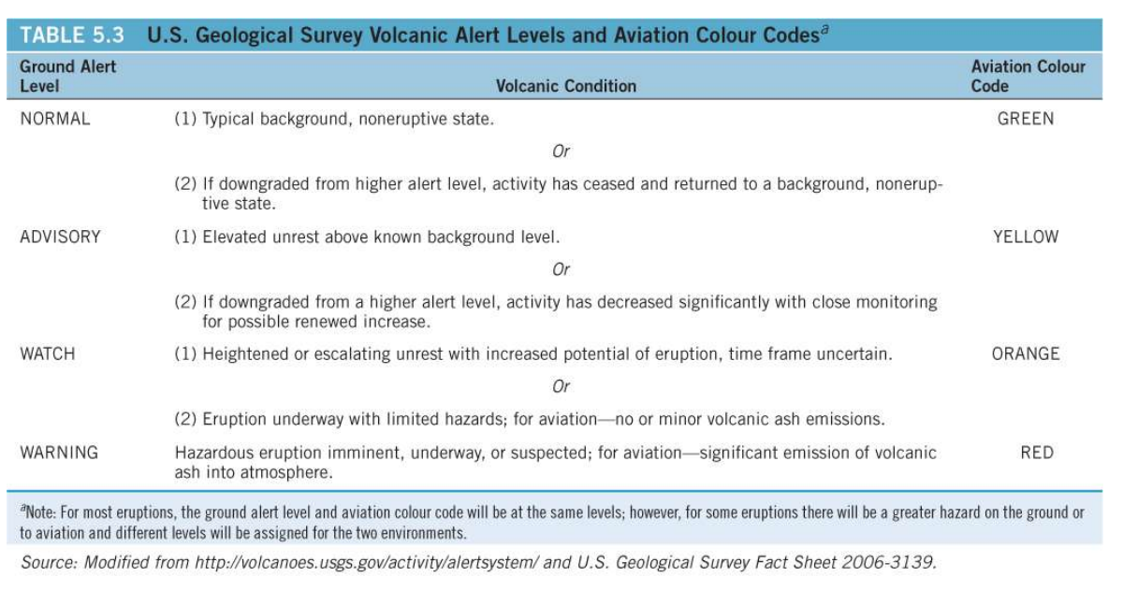

People live near volcanoes – place of birth, on some islands all land is volcanic, fertile land for farming, believe an eruption is unlikely, unaware of risk, economic limitations

Adjustments to volcanic hazards

* bombing – block the channels and cause the lava to pile up and break through upstream, where it will take a less damaging route
* hydraulic chilling effort – water used to chill and control lava flows
* wall construction – walls used to redirect lava flows